**Part 2**

**Step 1 : Calling Feature Extraction Method**

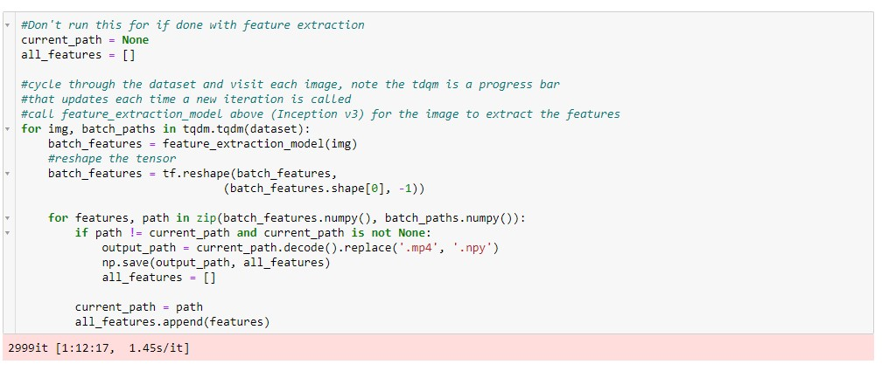

**Step 2: Creating MyLabelBinarizer**

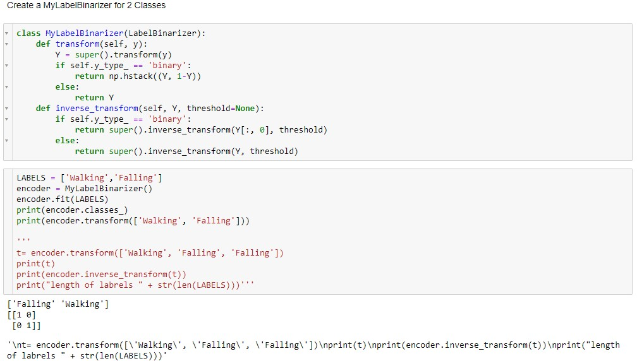

**Step 3: Setting Up Keras Sequential Model**

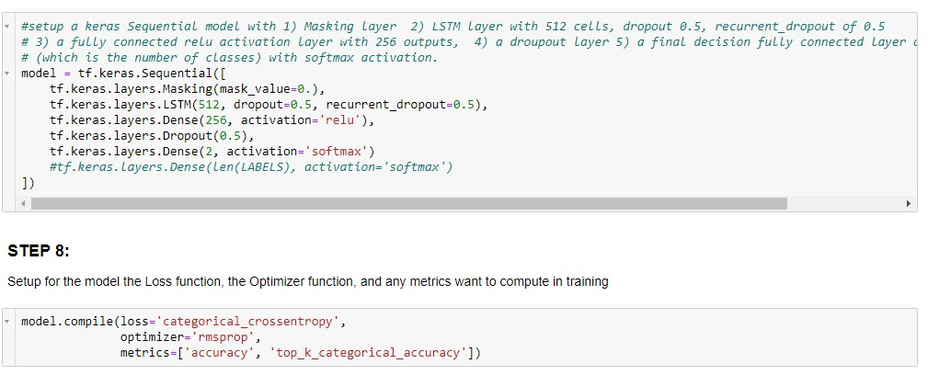

**Step 4 :Setting Up Training & Testing List**

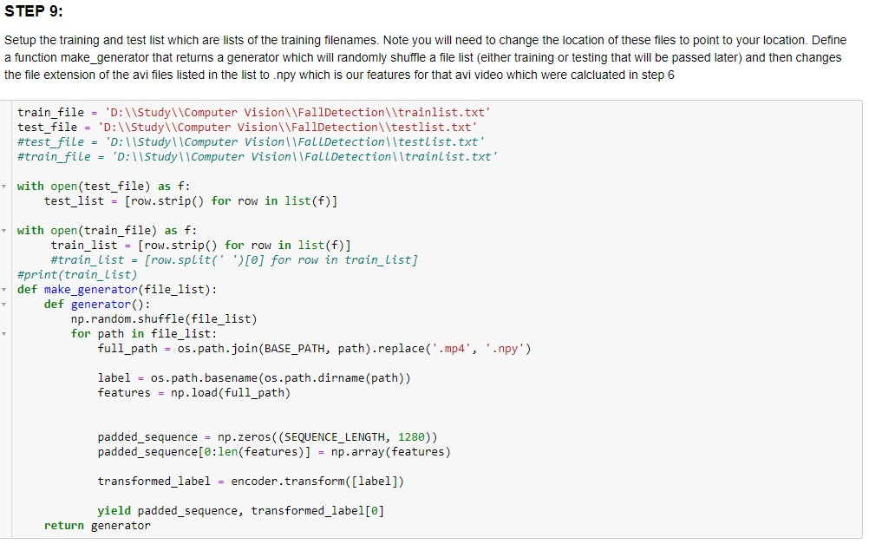

**Step 5: Train & Validate Dataset**

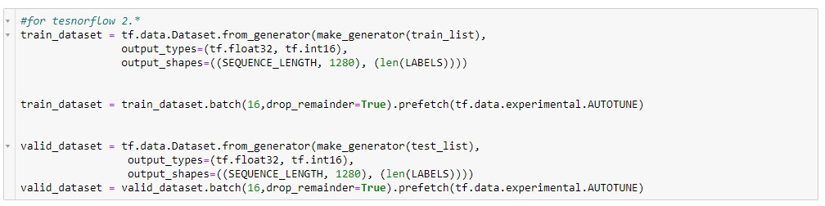

**Step 6: Model Fitting**

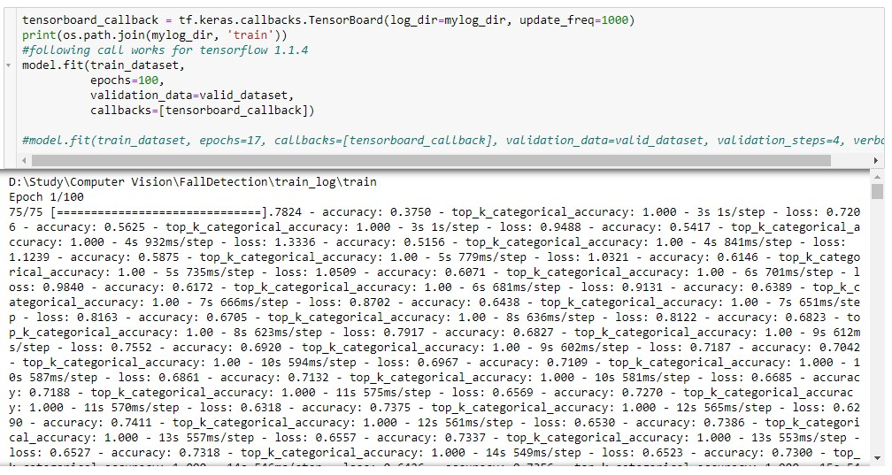

**Step 7: Saving the Model**

